Bo-taoshi
2-player dexterity micro game based on the Japanese sport of pole toppling

Components
6 discs - 3 each of 2 colors
2 poles
1 ramp

Goal
The first player to directly topple their opponent’s pole via air-borne strike wins the round; win 2 consecutive rounds to win the game.

Example of a scoring shot by black:

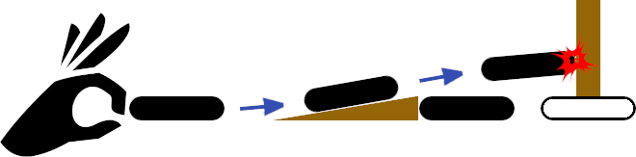

Setup
Note that ideal play surface is a smooth table or play mat 2-3’ per side

- Set ramp and poles aside
- Players choose disc colors and collect their 3 matching discs; white discs takes the first turn
- Note that the starting player alternates each round
- Players take turns flicking their discs into play from the edge of the table (or play surface)
- Discs start so that at least some portion is extending over the edge of the table



Setup continued
- Knocking another disc off the table during setup allows the other player to place the disc wherever they would like
- The 3rd disc to enter play for each player is their pole-bearer for the duration of the round
- Once it enters play place a pole on top of the disc; the pole-bearer cannot be flicked
- Should the black player’s pole-bearer knock over the white player’s pole during setup simply put the pole back

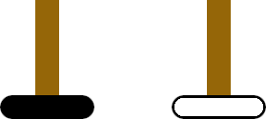

Game Play
Players take turns flicking 1 of their discs observing the following limitations in order:

- If the player’s pole-bearer was knocked off the table they must spend their turn to flick it back on to the table and place their pole on top
- If the player’s pole was knocked over they must spend their turn putting it back on top of their pole-bearer
- If the player’s previous shot was a foul they skip their turn as penalty
- The same disc cannot be flicked 2 turns in a row; note that the previous 3 limitations clear this limit since a turn has passed
- If the disc to be flicked was knocked off the table it enters play from the edge of the table
- If both of the player’s attacking discs are in play they may instead attempt to score a point (see next page)

Scoring
- Before attempting to score: place the ramp between the 2 attacking discs so that the taller side of the ramp is against the disc closest to the opponent’s pole-bearer



- If the ramp will not fit between the 2 discs a score shot cannot be made
- The further disc is then flicked in an attempt to travel up the ramp and knock down the pole while still air-borne

Scoring continued
- If the disc touches the table before striking the pole or the pole does not fall the ramp is removed and play continues normally
- If the attempt is successful the player wins the round, the table is cleared and the next round begins with a fresh setup
- If the same player scores 2 rounds in a row they win the game

Foul Shots
Flicking a foul shot causes the player to lose their next turn:

- Knocking over a player’s own pole is a foul; immediately place the pole back on top of the pole-bearer
- Knocking a player’s own pole-bearer off the table is a foul; the opponent immediately flicks the disc into play and places the pole on top

Note that losing a turn from replacing pole bearer or its pole does not count as the turn lost to a foul shot. The next time the player would be able to flick normally is when they would lose the turn from a foul shot.

